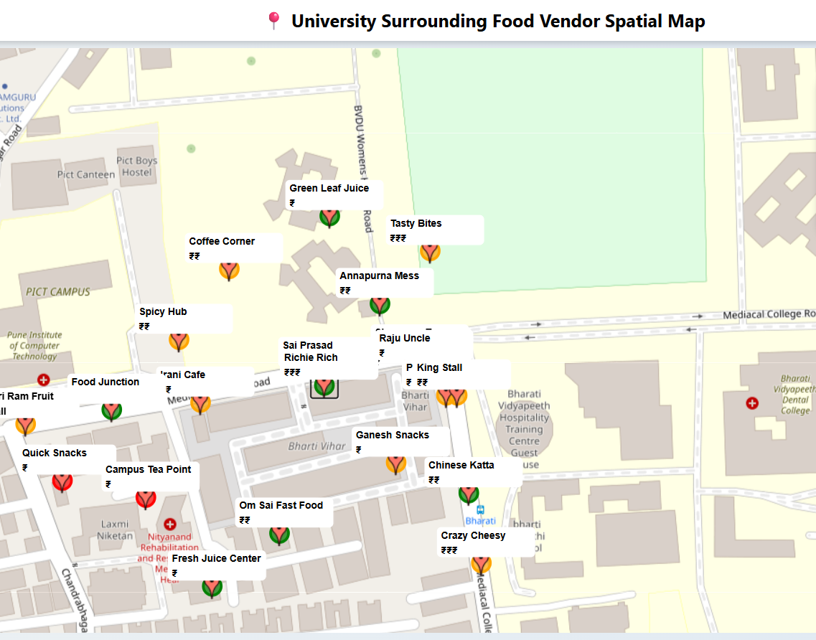  Interactive Web Portal using HTML and GeoServer | Name: SHRUTI DAWN  Roll No: 2515120009

- Task 1
Development of Interactive Web Portal
An interactive web portal was developed using HTML, CSS, and JavaScript for visualization of spatial data. The portal integrates web mapping functionality using the Leaflet JavaScript library.
The web map displays the spatial distribution of food vendors, cafes, and fruit shops around the university surroundings. The locations were plotted using latitude and longitude coordinates collected from the field.
Key Features of the Web Portal:
- Interactive zoom and pan functionality
- Display of 21 food vendor locations
- Popup information showing:
  - Shop name
  - Food quality (High / Medium / Low)
  - Price index (₹, ₹₹, ₹₹₹)
- Custom symbology:
  - Green → High Quality
  - Orange → Medium Quality
  - Red → Low Quality
- Legend integrated on map
- Sidebar showing spatial analysis
- Smooth zoom up to street-level (max zoom 22)
This portal helps in understanding spatial patterns, clustering, and accessibility of food vendors in the study area.

- Task 2:
Data Collection using Epicollect5
Field data was collected using the Epicollect5 mobile application.
A survey form was designed to collect the following attributes:
- Location Name
- Latitude & Longitude
- Type of Vendor (Food Stall / Cafe / Fruit Shop)
- Food Quality
- Price Range
- Opening Time
The collected data was exported and used in the web map.
- Epicollect5 Survey Form Design Screenshot
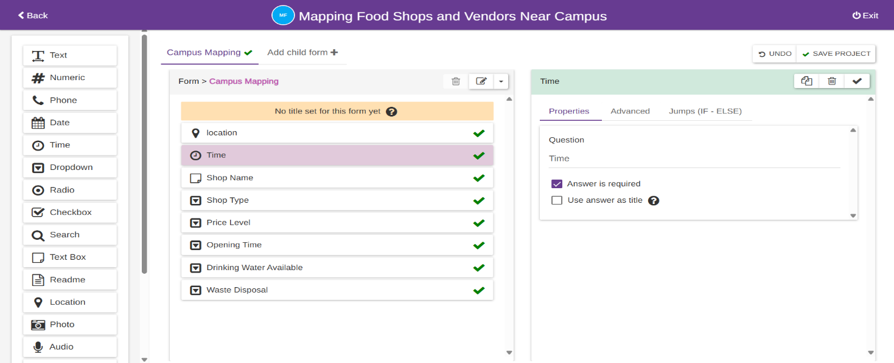
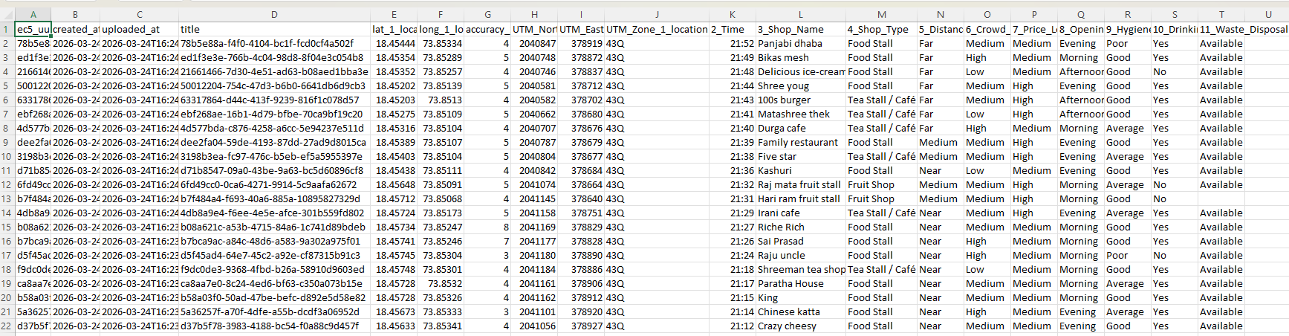
- Collected Data Table Screenshot:

- Web Map Portal Link
The developed interactive web portal has been successfully published using GitHub Pages for online access and visualization.
- Live Web Map Link:

Description
The web portal represents the spatial distribution of food vendors around the university area. It includes interactive features such as zooming, panning, and popup information for each location.
- Task 3
HTML Certificate
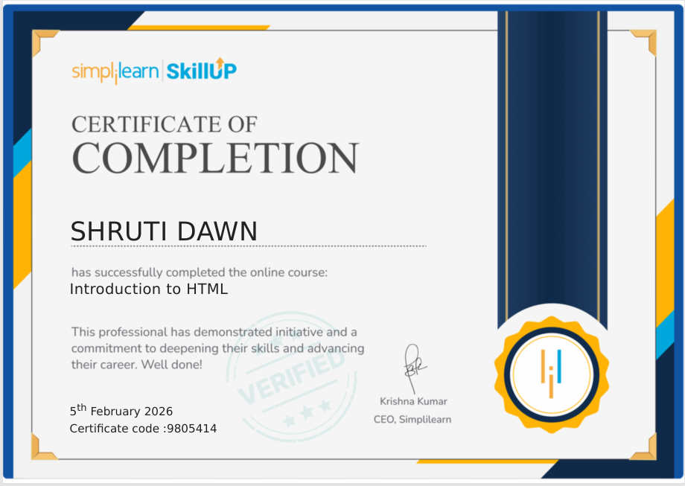
- Conclusion
This practical demonstrates the integration of GIS and Web Technologies to develop an interactive spatial visualization platform. The project highlights how geospatial tools can be used for real-world problem analysis, such as food accessibility and urban services.

